Grande Rivière Capital of “Greater Madawaska”
By Jacques F. La Pointe

At the end of the 19th century and beginning of the 20th century, the old settlement of Grande Rivière was, indeed, the most important demographic, commercial, and industrial center of the great territory of Madawaska (both American Madawaska and Canadian Madawaska).

In 1900, with its 1,878 inhabitants, Van Buren was the undisputed capital of the American Madawaska. In 1901, Saint-Léonard had 2,738 inhabitants. Comparatively, in 1901, the village of Madawaska, the future city of Edmundston, had 1,882 inhabitants and the population of the Grand Falls region totaled 1,253.¹

Commercially, at the beginning of the century, the twin municipalities of Van Buren and Saint-Léonard hummed with activity.

In that era, important railway and road construction as well as development of the forest industry at the end of the 19th century and beginning of the 20th century gave rise to an important commercial center in Saint-Léonard. Moreover, it is equally important to stress that Saint-Léonard was, at the time, the provisioning center for several new communities now developing at the northern center of the province of New Brunswick, places such as Grimmins, Anderson Siding, Richard’s Station... and others. Consequently, large general stores, inns and bars multiplied in Saint-Léonard.

It is at that time that gentleman farmers such as B. R. Violette and Damas Martin more or less retired from the agricultural and dairy industry to become merchants. The classified advertisements in the newspaper Le Madawaska of Van Buren, Maine have left us vibrant proof of the increasingly important commercial importance of the village of Saint-Léonard at the beginning of the 20th century.

“Attention everyone At the New Store You will find a complete and varied assortment of Provisions, Groceries, Dry Goods, Shoes, Hats and General Supplies for Messieurs, Tea, Tobacco, Cigars, Fresh and Salted Fish, Meat and Hams, etc.

In addition to our ordinary stock we have added a large and nice assortment of Clothes (Hardes) Made for Messieurs, Young People and children.

Also we have considerably increased our stock of shoes, for all feet. We solicit your business.

We buy for money or goods all your farm products. Sleepers, etc.

F. E. Rivard, Prop. St-Leonard, N.B. ”²

“GENERAL STORE
We always have at the Public’s Disposal:

Dry Goods, Clothing, Shoes,
Hats,
Shirts and Pants,
Material for Dresses,
Trimmings, Stylish dresses and fantasy items
Provisions, Groceries, Tea,
Sugar, Tobacco, Cigars,
Canned preserves,
Cookies, Candy, etc.
We invite Everybody

FRED A. ROY
St. Léonard, N.B.”³

“Chas. L Cyr
Licensed Business
Beers, Wines, Liquor, Cordials, etc, etc.
Tobacco and Cigars
St. Leonard, N. B.”⁴

In the same line of thought, it is necessary to quote Alphé Michaud, whose father owned a general store in Saint-Léonard at that time:

“…Mills operated and money rolled in. We had a store at home, us ... and I do not lie to you, in those days we had... slot machines, and we had two in the store, one five cents and one twenty five cents that worked really well, steady. People went to the woods... they left in autumn and came back at Christmas...and then they celebrated. I saw barrels of apples sold at our store, containers of chocolates, containers of mixed candy. Yea, I remember that really well. The money rolled and it rolled, it goes without saying. Nobody borrowed money, they worked for their money...”⁵

In effect, the many logging camps on the Restigouche, the Kedgwick, and Grande-Rivière and the hundreds of loggers who got there by railroad in Saint-Léonard, were also an important source of income for the merchants.

Consequently, many hotels with restaurants and bars opened in Saint-Léonard, in order to accommodate the important flood of travelers in the village. There were the Dufferin, Desrosiers, Accommodation, Violette, Bellefleur, Brunswick, Cyr Hotels and several others...

At the time, the hotels, restaurant operators, grocers, outfitters, barbers and blacksmiths all made up the basis of an extremely prosperous business class in Saint-Léonard. A class of professionals joins the group of merchants and at the beginning of the 20th century at least three doctors had opened their practice in Saint-Léonard, Doctor L. M. LaPointe, Dr. J. Thériault and Dr. L.-J. Violette. The Red Cross Hospital in Saint-Léonard also treated patients from both sides of the Saint John River.

Violette Hotel

Bellefleur Hotel (Brunswick)

Cyr Hotel

Charles Cyr, owner of the Cyr Hotel and Member of the Legislative. Assembly, standing behind his counter

Mr. Charles Cyr’s home

Van Buren, too, attracted many new merchants and professionals, as a result of its rapid and remarkable economic development. Indeed, from a population of 1,878 inhabitants in 1900, Van Buren increased in number to 3065 inhabitants in 1910 and 4,594 inhabitants in 1920. Martine A. Pelletier, in her book Van Buren Centennial 1881-1981, emphasizes this rapid growth and prosperity.

“Van Buren flourished... Several large emporiums were built between 1900 and 1920… clothing and grocery stores mushroomed, the Dreamland Theatre was built, drug stores, barber shops, stables, blacksmith shops all those businesses and services vital to a growing metropolis’ needs seemed to sprout overnight. The coming of the railroad on November 23, 1899, brought tourists and hotels were added to the town’s industries. A new international bridge, the first to be erected in the upper St. John River, replacing ferries and linking Van Buren with its neighbor St. Leonard, N.B. The telephone and telegraph were introduced in 1904-1905, electricity for all public buildings in 1909-1971. Schools were enlarged and a tannery, starch and berry factories were built. Il was an exhilarating time.”⁶

In the manufacturing sector, the mills on the two banks of the old settlement provided boards, beams, shingles, wood boxes and other manufacturing products that were sold not only on the North-American continent but also on the European and South American markets.

The Michaud Mill (1890-1920)

In 1890, Thaddé Michaud of Saint-Léonard builds a sawmill not far from the mouth of the Grande Rivière. The northern bank of the old settlement now has its own sawmill.

At the beginning of the twentieth century, this mill burns down and is immediately rebuilt at the cost of $16,000.

Under the able direction of Thaddé Michaud, this mill prospers. During the war of 1914-1918, the mill fabricated wooden boxes which were used to transport American military weapons. It also sawed soft wood and made shingles.

In 1920, Thaddé Michaud has no alternative but to sell his mill. In fact, at that time James Burgess from Grand Falls had obtained a license to cut wood on some Crown land situated just inland from Grande Rivière. Thaddé Michaud, himself, had tried on several occasions to obtain this reserved land located just to the north and right behind the woodlot of his own mill but without success. Burgess’ license greatly limited expansion plans for the Michaud mill. Burgess was well aware of this. He did not delay in taking advantage of this opportunity; he offered to buy Michaud’s mill for the sum of $6,000 and included a guarantee of employment for the Michaud family at said mill. When Michaud refused, Burgess built a dam on the upper part of Grande Rivière, which had the double effect of depriving the Michaud mill of an important source of water and also blocking Michaud’s access to his wood reserves located higher up on the river. Thaddé Michaud no longer had a choice. The sale of his mill was inevitable.

The Burgess Mill (1920-1930).

The Burgess Mill quickly became the main employer in Saint-Léonard. On the average, 300 men worked in the mill and in its logging camps. In summer, they sawed softwood and in the winter, hardwood. Wood for the mill operations came from Crown lands, today the property of the Irving Company. Manufactured goods, such as shingles and boards, were sold in markets of the province and in the United States. Several cargoes were shipped on boats from the port of Dalhousie, New Brunswick. The annual production of this mill totaled approximately 10 or 12 million feet of wood per year.⁷

On-site at the mill, the loggers had the right to use a large kitchen, a dinner hall, a dormitory and a room transformed into a small barbershop.

Other mills in Saint-Léonard (1890-1930)

From 1890 to 1930, there were also several other mills in the Saint-Léonard area. Their economic impact was not as important as that of the mill built by Thaddé Michaud and sold to James Burgess, but they contributed all the same to the economic prosperity of the community at the beginning of the century. Among the latter, we mention the mills of Nelson Pelletier, F.B. Soucie, Albénie J. Violette, Antoine Clavette, Adolphe Daigle, Paul Daigle, Cyrille Martin and others.

The American Mills.

It was in Van Buren that the first important mills on the upper Saint John River were built. Many Canadians including a large number of Saint-Léonard citizens worked there.

In 1903, the Milliken brothers of Stockholm and Augusta (Maine) founded the St. John Lumber Company, in Keegan. This mill was not only the largest mill in Van Buren, but from 1907 was also referred to as the most important mill in the State of Maine, in the area east of Mississippi and even designated as “the world’s largest lumber mill ”.⁸

Very early in its history, St. John Lumber Co. employed approximately 400 people in the mill and during the wood cutting in the winter, added 1,500 men to the payrolls of the company. As early as 1908, this mill manufactured up to 250,000 feet of board and 500,000 shingles per day.

The Van Buren Lumber Co. of Van Buren was also an important mill where several people from Saint-Léonard worked. It was not difficult at that time to live or to work on one side or the other of the Saint John River, between Saint-Léonard and Van Buren. In this respect, we quote the June 15, 1904 edition of the Van Buren newspaper, Le Madawaska.

“Mr. Alfred Cyr of Presque Isle who is employed by the Van Buren Lumber Co. has moved his family to St. Leonard, N.B.”⁹

American Consular Agency in Saint-Léonard, 1916.

Confirming the economic importance of the Grande Rivière area, the American government opens an American Consular Agency in Saint-Léonard in January of 1916.*¹⁰

Forestry operations

Logging camp in the backwoods of Saint-Léonard

Mr. Épiphane Nadeau’s logging operation

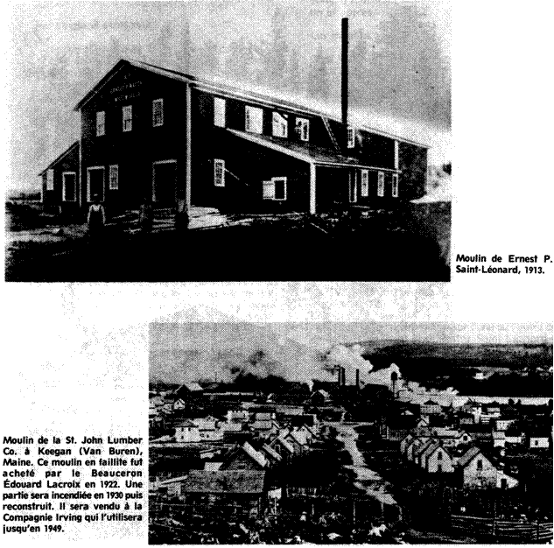
Mill belonging to Ernest P. Saint-Léonard, 1913

St. John Lumber Co. Mill in Keegan Maine. This bankrupt mill was b ought by Beauceron Édouard Lacroix in 1922. A section burned in 1930 and was rebuilt. It was sold to Irving Company who operated it until 1949.

St. John Lumber Co. since 1907, one of the most important sawmills in the United States and possibly in the world

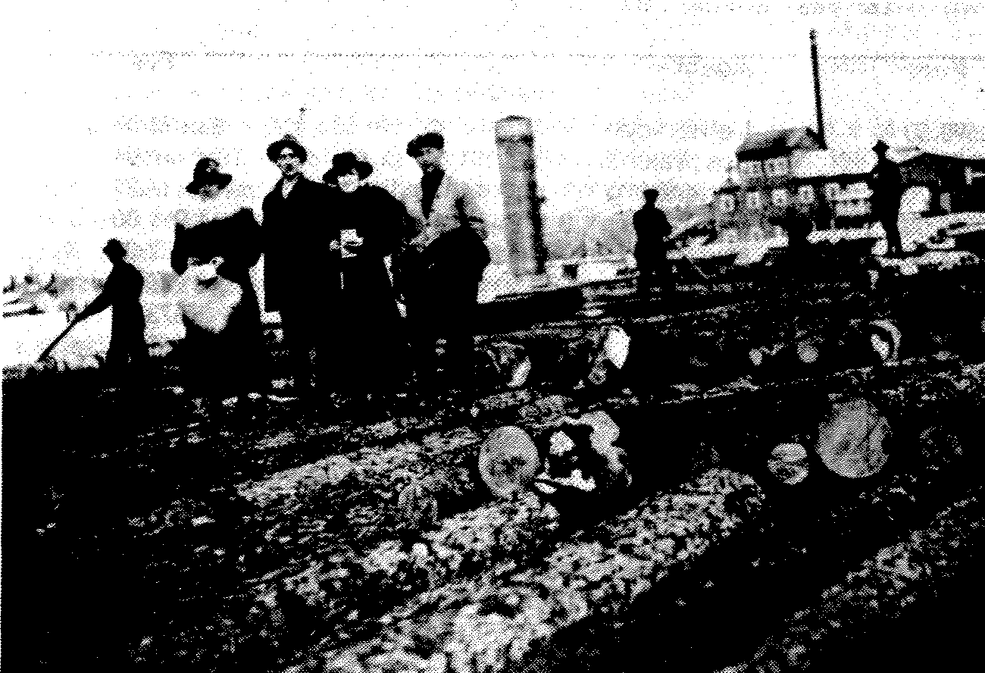
The Van Buren Mill at the turn of the century

Several American industrialists of the time actively supported the opening of the agency in Saint-Léonard. In this respect, we quote Percy R. Todd, president of the Bangor & Aroostook R.R. Co. and Allen E Hammond, owner of Van Buren Lumber Co.:
“ November 23, 1915
Hon. Chas. F. Johnson
Waterville, Maine.

My dear Senator Johnson: -

CONSULAR AGENCIES
................................
St. Leonard is the junction point of the American Railway system through the Bangor & Aroostook and the Van Buren Bridge with the new Transcontinental Canadian Government Ry… and also junction with the older Canadian Gouvernment Ry. system known as the “Inter-colonial Ry.”, and a large volume of freight traffic is moving from Canada to the United States by this route...

I would state that we regard this as so important, not only in the interest of this railroad company but of its many patrons, that if absolutely necessary our railroad company would be willing to contribute something toward the expense of maintaining a consular agency at St. Leonard...

Yours Truly
Percy R. Todd
President”¹¹

December 1, 1915
Hon. Chas F. Johnson,
United States Senate,
Washington, D. C.

Dear Senator,
................................
St. Leonards, N.B., is now a railroad center. The International Railway has its terminus at St. Leonards. The Canadian Pacific and the National Transcontinental also furnish business and these all connect with the Bangor & Aroostook by the new international railroad bridge. I am only one of many shippers but I will have 3000 cars of lumber to bring across the bridge in the course of the coming year.
...We ask that you use your good offices to have a consular agent appointed at St. Leonards, N.B.
St. Leonards, N.B., is a logical place for the consular agency.

Very truly yours,
A.E. Hammond”¹²

On January 20, 1916, at the official opening of this Consular Agency in Saint-Léonard, few could predict the enormous success and the importance, which this service was to have. Indeed, in terms of trade and custom duties levied, the American Consular Agency in Saint-Léonard quickly became the most important of the province and even possibly of Canada. Remarkably, on a list of sixty-six American Consular Agencies enumerated in the world, that of Saint-Léonard was most important in terms of levied custom charges. The following illustrates this fact:

The success of the agency in Saint-Léonard is such that the Department of State in Washington eventually receives several requests to raise the Consular Agency’s status to that of a Consular Office (Vice Consulate). We quote a letter from Frederick Hale, senator from Maine in Washington and president of the Committee on Naval Affairs of the American Senate, who speaks on this matter.

“ Portland, Maine, July 27, 1925.
Hon. Frank B. Kellogg,
Secretary of State,
Washington, D. C.

Dear Mr. Secretary: -
At the present time the United States has a Consular Agent stationed at St. Leonard’s but no Vice-Consul. The Consular Agent of course may not issue passports, and the nearest places at which passports are obtained is Campbellton, N. B., a distance of over one hundred and fifty miles from St. Leonard’s. A good many people come across from St. Leonard’s to Van Buren, Maine, which is just across the river. Under the circumstances would it not be possible to appoint a Vice-Consul at St. Leonard’s in addition to the Consular Agent there?...
Sincerely yours,
Frederick Hale”¹⁴

Mr. Alphonse Labbé, Consular Agent in Saint-Léonard, also justifies the elevation of the status of the agency to that of Consular Office. Here is the extract of a letter, which he forwards to Mr. Thomas W Chilton, of the American Consular Office in St. Stephen, on this subject:

“…
The United States immigration authorities in Van Buren inform me that in view of the impossibility of obtaining Visas in St. Leonard, many misguided persons attempt to enter the United States illegally at this point, and there are now a considerable number in jail on the American side awaiting deportation proceedings. If appointed Vice Consul, I shall be able to grant at least an average of 500 Visas per year…
Your obedient servant,
Alphonse P. Labbé American Consular Agent ¹⁵

The answer of the Secretary of State to this request was as follows:

“Dear Senator Hale,
... In reply I regret to inform you that inasmuch as the Department already finds it difficult to meet the demands for additional career personnel at offices in many parts of the world, there is no career officer available for assignment to St. Leonard’s at the present time.
Sincerely yours,
Frank B. Kellogg”¹⁶

Ironically, a few years later, because of disastrous economic circumstances, the Consular Agency was forced to close its doors permanently. The last report of the Agency was dated July 1, 1934 and showed the collection of (only) $106.50 of custom duties.

In fact, the closing of the Agency coincides with the end of an economic golden era on the banks of Grande Rivière.

Hope Dashed Unexpectedly

Owing to a sad combination of circumstances during the 1930’s, the dream of unending prosperity for Saint-Léonard and Van Buren did not materialize. The closing of sawmills because of the increasing competition on the markets; sometimes the absence of modern equipment; the devastations caused by serious fires at the most important mills, such as the fire at Lacroix Mill in 1930 (old St. John Lumber Co.): all this followed the depression of the 1930’s, and severely shook the economic base of these two municipalities. An exodus of its inhabitants towards the industrial centers of New England and the change of the economic and commercial center of the Upper Saint John River Valley to Edmundston and Madawaska (Maine) confirmed the end of a golden era in Grande Rivière.
"Fees collected at consular agencies for the fiscal year ending June 30, 1927.
Agency Fees Agency Fees
Annapolis Royale $598.50 Lethbridge $3,094.00
Arequipa¹ Arequipa¹ 353.43 Los Mochis 116.00
Bathurst 3,839.00 Lunenburg 1,117.32
Beebe Junction¹ 1,878.00 Manzanillo 1,059.00
Bloemfontein¹ 4.00 Matagalpa¹ 12.00
Bocas def Toro 595.00 Medellin¹ 236.50
Bonacca 114.00 Mollendo¹ 673.68
Brighton 846.50 Nanaimo 2,097.50
Caibarien 1,455.00 Newcastle 3,739.00
Cananea 697.00 Ocean Falls 634.00
Ceara¹ 952.54 Oran 1,745.36
Christchurch 1,955.54 Paita¹ 1,025.69
Ciudad Bolivar¹ 315.79 Paramaribo 846.54
Coquimbo 289.61 Port de Paix 424.50
Cruz Grande 276.00 Port Hawkesbury 912.00
Cumberland 717.50 Puebla¹ 645.50
Cyprus¹ 270.06 Puntarenas¹ 733.00
Dieppe 224.36 Rio Grande 251.33
Dunedlin 1,715.78 Roseau¹ 819.39
East London 218.98 Sagua la Grandel 430.50
Esmeraldas¹ 247.50 St. George's 572,50
Flushing 392.96 ST. LEONARD 22,557.00
Fremantle-Perth 456.18 St. Lucia¹ 591.00
Galway¹ 414.89 St. Marc 290.00
Gaspé 354.00 Salaverry¹ 545.90
Gonaives 406.50 Sanchez 1,531.00
Grenada 1,317.00 San José, Guatemala 1,389.00
Jérémie 406.00 San Pedro de Macoris¹ 906.00
Jersey 125.00 San Pedro Sula 114.00
Kalamata 607.50 Summerside 984.00
Kenora 5,387.50 Talcahuano 1,220.42
La Oroya¹ 22.00 Tarragona 1,142.49
La Romana 1,175.00 Tuxpan 91.50
¹(Incomplete returns) "¹³

It is interesting to note, in summation, the comments of some of the inhabitants of Saint Léonard and Van Buren who witnessed the sad fate of their small villages during the period beginning with the 1930’s:

“A little too trustful of the permanence of their privileged economic status, the inhabitants of Grande Rivière did not adapt and diversify their industries quickly enough to the requirements of the twentieth century. The fortunes were made to serve the day-to-day short-term needs and the long-term investments were, as a result, neglected. Many were the fortunes lost at Grande Rivière! In addition, once the crisis passed, human resources and the financial capital necessary for an impressive industrial recovery were not there any more. A dream of continual prosperity was coldheartedly stopped at Grande Rivière.”¹⁷

A Reconstruction Effort.

It is important to stress that not all stopped in Saint-Léonard with the closing of the mills and the economic crisis of the 1930’s. Certain contractors still had confidence in the future of the municipality. In 1930, Ernest Nadeau opens a new mill within the limits of the town of Saint-Léonard. He receives enthusiastic support from the community for this project and the first important contract, which he receives, is to provide all the windows and the doors for the new school under construction at that time (presently the Fernande-Bédard School). In addition, during the 1930’s, 1940’s, and 1950’s, several companies set up or expanded in Saint-Léonard. Among these were Madawaska Weavers, Daigle Motels, the Acadia Restaurant and Theatre, J.H. Malenfant Grocery, Daigle Insurance, Morneault Hardware...etc.

The Chamber of Commerce, the Industrial Park, and the Association of Merchants and Entrepreneurs of Saint-Léonard.

The business community in Saint-Léonard resurges dynamically at the beginning of the 1960’s, with the founding of the Chamber of Commerce.* Some of its first slogans were: “For the Good of the Town” and “Saint-Leonard Future Industrial Center.”

Enclosed, you will find an extract of the official Minutes of the first meeting to organize the Saint-Léonard Chamber of Commerce on February 23, 1961:

“This meeting said to be ’organizational’ was called by Messrs John A. Cyr and Aurèle Beaulieu...

M. Roger Levesque, president of this evening’s meeting, welcomes the people present and introduces the first invited speaker, Mr. Roger Rhéaume, former president of the Edmundston Chamber of Commerce.

A second speaker, Mr. Leon Cyr of Clair, N. B. lends Mr. Rhéaume a hand by giving necessary explanations about the organization of a Chamber of Commerce.

It was decided to take one week to reflect and to brief everyone.

Concluding remarks by Reverend. C.V. Leclerc.
Roger Levesque, Pres.
Dr.Régis Levesque, Secretary ¹⁸

On March 14, 1961, took place the election of the first executive of the Saint-Léonard Chamber of Commerce. The following people were elected: James E Cyr, President, Marcel Cyr, Vice-President and Roger W Levesque, Secretary-Treasurer. ¹⁹

Next on March 24, eight directors were elected. On April 7, 1981, following are the directors and the committees they preside:

W.H. Violette Industries
John A. Cyr Recruiting
Edgar Dionne Agriculture
B.E. Boucher Education
Eddie Soucy Retail Merchandising
Réal Gervais Delivery and Transportation
Albéo LaPointe Tourism et Publicity
Robert Côté Programs for Emergency Aid and
Civic Spirit²⁰

On April 14, 1961, the Honourable J-Adrien Levesque, Minister of Agriculture, New Brunswick, was the first guest of honor to officially address the members of the Saint-Léonard Chamber of Commerce. The Minister commented, “That even if the Chamber of Commerce was only at its beginnings, enthusiasm seemed to be great and augured well for the future.”²¹

In 1989, the Chamber bears the name of Regional Chamber of Commerce of Saint-Léonard and consequently, represents not only the interests of the town, but also those of the neighbouring communities of Saint-Léonard-Parent, Siegas and Notre-Dame-de-Lourdes.

With respect to the most important initiatives undertaken in the past by the Chamber of Commerce, in collaboration with the town council and some local businesses, it is important to underline the preparation of an affirmative action strategy, during the years 1960, to attract new industries to Saint-Léonard. Information booklets and various studies are prepared in order to promote the town and identify its economic potential. Several projects are considered such as a brickyard, a furniture manufacturing industry, a carpet manufacturing industry, etc. The first project they pursued was building a sawmill to cut structural timber. Consequently, from 1961 on, the municipality and some local businesspersons undertake the construction of a sawmill within the limits of the city. This new sawmill, known as St. Leonard Industries, is soon sold to a group of contractors from Montreal. Ted Pratt, of Montreal, is the boss. It is common knowledge that 90% of the timber produced at this mill was exported to the United States. The office of this company was located near the mill. Geraldine Cyr was the secretary; Jim Trainer the truck-driver and a score of employees worked in the sawmill. Regrettably, St Leonard Industries mill was in operation for only a few years.

In spite of the insolvency of this project and the lack of success with other projects, several citizens of Saint-Léonard had been mobilized by these initiatives of the Chamber of Commerce and the municipality. Some of them would never give up their dream of industrialization for Saint-Léonard. It is also important to note that in 1975, the municipality develops a parcel of land, in order to prepare it for an industrial park. Saint-Léonard would be one of the first French-speaking municipalities of New Brunswick to provide itself with such an industrial park. In 1989, there are five companies in the Saint-Léonard Industrial Park; they are Cerceuils Brunswick Caskets; A.N. Industries Ltée. (shingles mill); Confection 4ième (4th) Dimension Ltée. (clothing manufacturer); V.L.O. Foods Ltd. (producer of Acadian chicken fricot (stew) and Entreprises Soucy (manufacturer of log homes)

Moreover, in 1988, the Association of Merchants and Entrepreneurs of Saint-Léonard is founded. The objectives are specific: to protect the jobs already existing, to create new jobs, and to ensure the future development of the business community in Saint-Léonard.

Despite the struggles of the past, people of Saint-Léonard always stayed confident about the eventual revival of important economic activity in their small town. In addition, the announcement and especially the start of construction of the J.D. Irving Mill in Saint-Léonard, in 1988, seem to confirm the population’s hope of great prospects for their municipality.

Equally encouraging are the reopening of the Van Buren mill, newly owned by Gilbert & Bennett Company and new developments in the industrial park of this beautiful Aroostook locality .

¹Canada Census, 1901, New Brunswick Public Records New Brunswick, Fredericton.

²Le Madawaska, "Classified Advertisements", Van Buren, Maine, 1903, p.5.

³Ibid., August 6, 1903.

⁴Ibid., p.4.

⁵Interview with Mr. Alphé Michaud, Grande-Rivière Archives, Saint-Léonard.

⁶Martine A. Pelletier, Van Buren Centennial 1881-1981, p. 64.

⁷Rapport objectif quatre, Workshop to Research the Locality, Saint Basile, New Brunswick, Canada Works Project, September 10, 1971, C.D.E.M., Edmundston, p. 16.

⁸Leonard W. Hutchins, “Edouard ' King' Lacroix, Paul Bunyan of the North Woods”, Down East the Magazine of Maine, March 1977, p. 47.

⁹Le Madawaska, June 15, 1904, St. Leonard N.B., Van Buren, Maine, p. 1.
¹⁰*Do not confuse with the Consular Office or Consulate. The Consular Agency cannot issue visas and is under the direction of a Consular Office. The Consular Agency in Saint-Léonard was under the direction of the Consular Office in St. Stephen, N. B, which in turn was under the direction of the American Consulate in Halifax.

"Opening of St Leonard Agency", Official letter of the Government of the United States, signed on January 24, 1916, by the American Consul in St. Stephen, N. B Department of Secretary of State, Archives, Diplomatic Branch, Washington, D.C., Documents 125.

¹¹Correspondence of the Department of State, Office of the Director of Consular Affairs, Washington, D.C. Copies in the Grande Rivière Archives.

¹²Ibid.

¹³"Fees collected at consular agencies for the year ending June 30, 1927", Grande Rivière Archives.

¹⁴Correspondence from Department of State, Washington, D.C., Document 125.81784/22.

¹⁵Ibid., Document 125.81784.

¹⁶Ibid., Document 125.81784/35.

¹⁷Collections of recorded and written interviews with the inhabitants of Saint-Léonard and Van Buren; Grande Rivière and Saint-Léonard Archives,; Private archives of Martine A. Pelletier, Van Buren, Maine.

¹⁸*In the 1920’s, following the incorporation of the town, there was a "Saint-Léonard Board of Trade". This association dissolved in the 1930’s, without leaving behind a constitution or minutes of meetings.

Official records of Minutes of Meetings, the Saint-Léonard Chamber of Commerce , Archives of the Regional Saint-Léonard Chamber of Commerce of, pp. 2-3.

¹⁹Ibid., p. 5.

²⁰Ibib., pp. 7-8.

²¹Ibib., p. 9

The brickyard in Saint-Léonard at the beginning of the century. At the extreme left, Rodolphe Rivard and his father Fred Rivard. Lévite Michaud is in the white hat and white shirt.

